**Creating a Data Factory in Azure**

**Step 1: Navigate to Azure Data Factory**

1. In the Azure portal.
2. Search for **Data Factory** in the search bar.
3. Select **Data Factory** from the results and click **Create**.

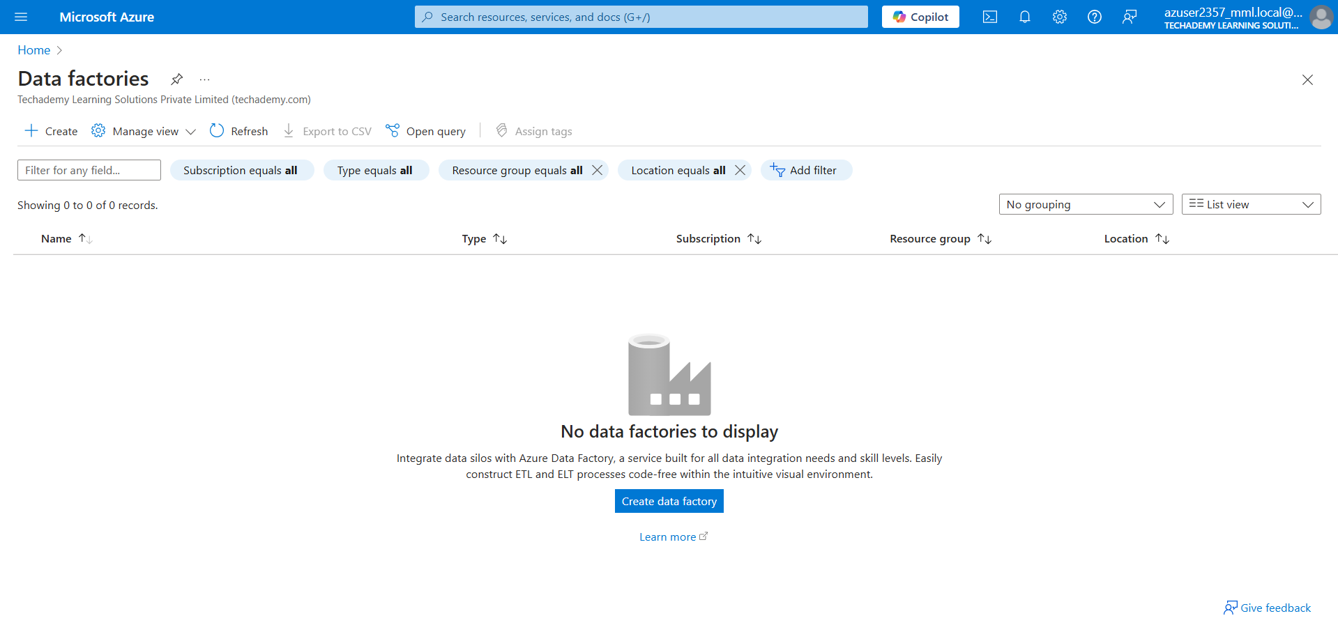

**Step 2: Configure the Data Factory Basics**

1. **Subscription**: Choose your Azure subscription.
2. **Resource Group**: Select an existing resource group or create a new one.
   * Click **Create new**, provide a name, and click **OK**.
3. **Region**: Select the location where you want your Data Factory to be deployed.
4. **Name**: Provide a unique name for your Data Factory.
5. Click **Review + Create**, then click **Create** after the validation is successful.

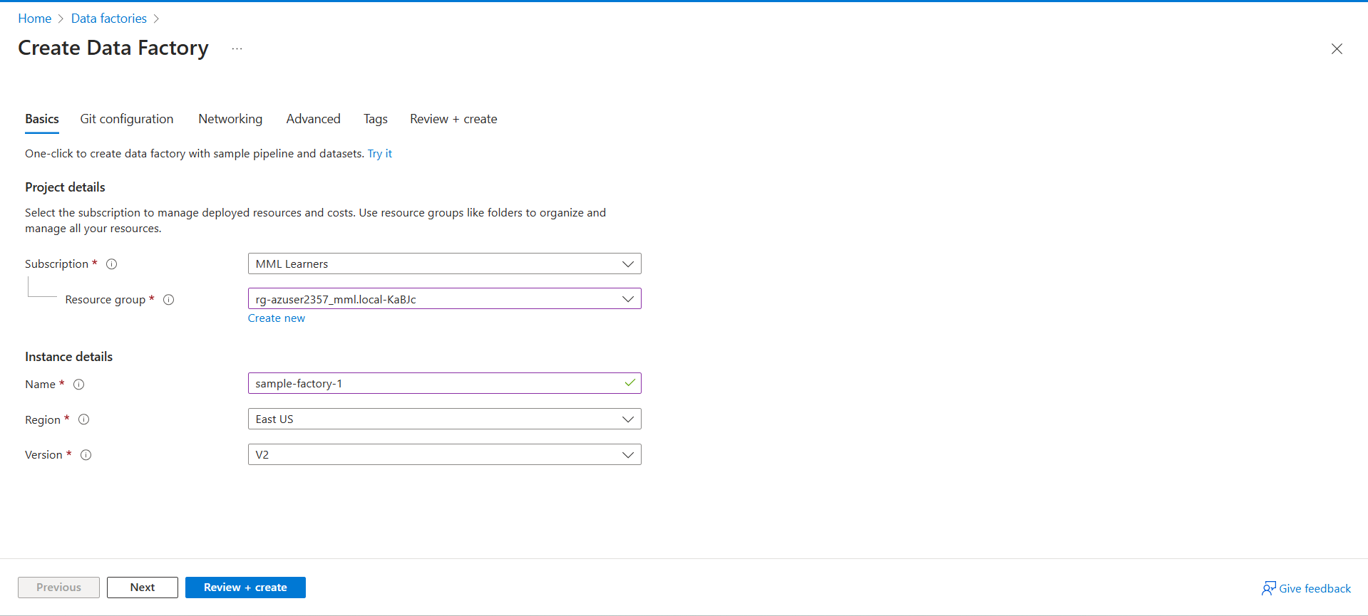

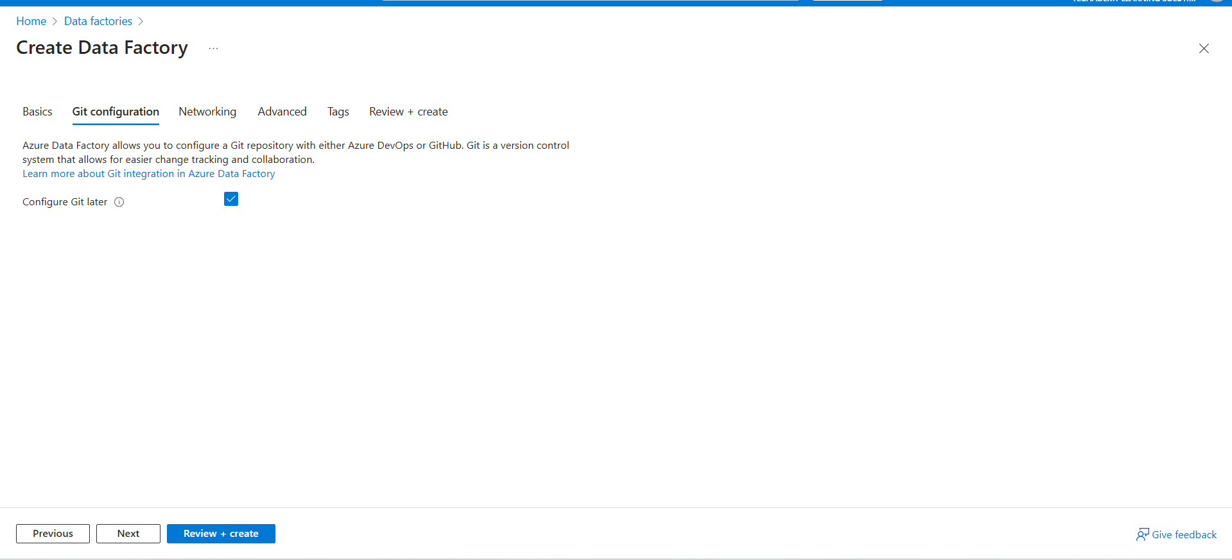

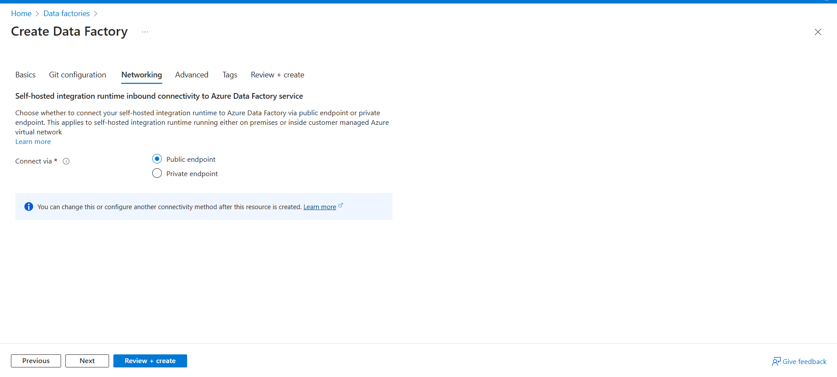

**Step 3: Wait for Deployment**

* Once you click **Create**, Azure will start deploying your Data Factory.
* Wait until the deployment is complete

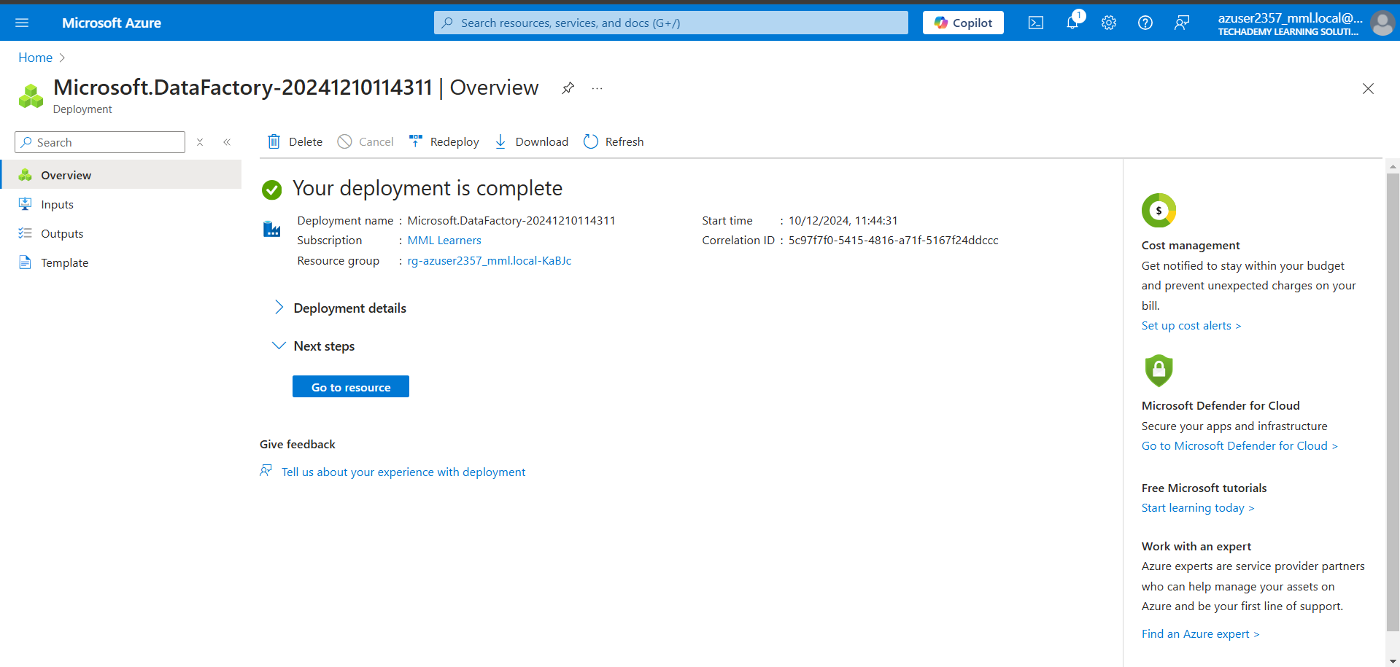

**Step 4: Open the Data Factory**

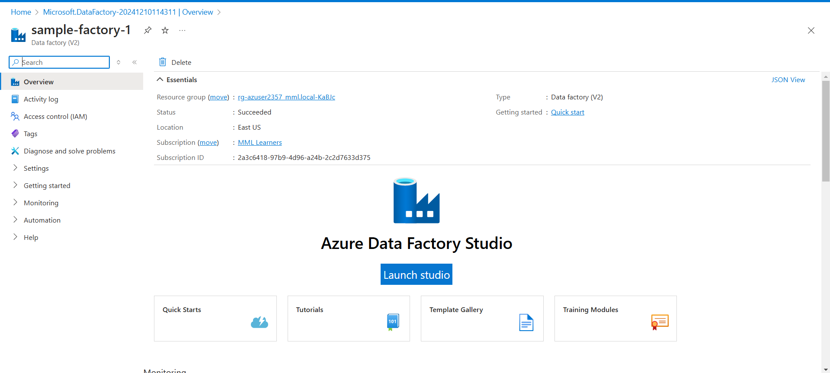

**Create a Copy Task in Azure Data Factory**

**Step 1: Launch the Copy Data Tool**

1. From the **Home** page of the Data Factory UI, locate the **Copy Data** tool under the "Intake and prepare" section.
2. Click on **Copy Data** to open the tool.

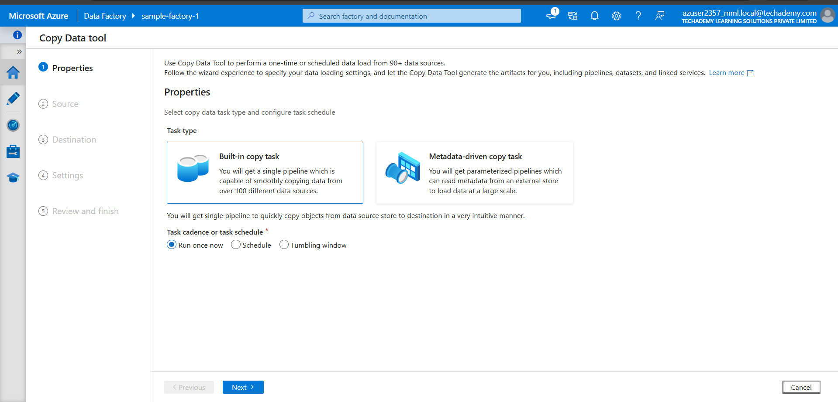

**Step 2: Configure the Copy Task Basics**

1. **Task Name**: Enter a name for your task.
2. **Task Schedule**: **Run once now**: If you want the task to execute immediately.
3. **Choose Data Source**: Select a data source from the list of linked services or create a new connection by clicking **+ New Connection**.
   * For instance, if you select **Azure Blob Storage**, provide the necessary credentials
4. **Select the Data**: Choose a file, folder, or dataset from the source.
   * Browse for the file/folder or provide a path manually.
5. Click **Next**.

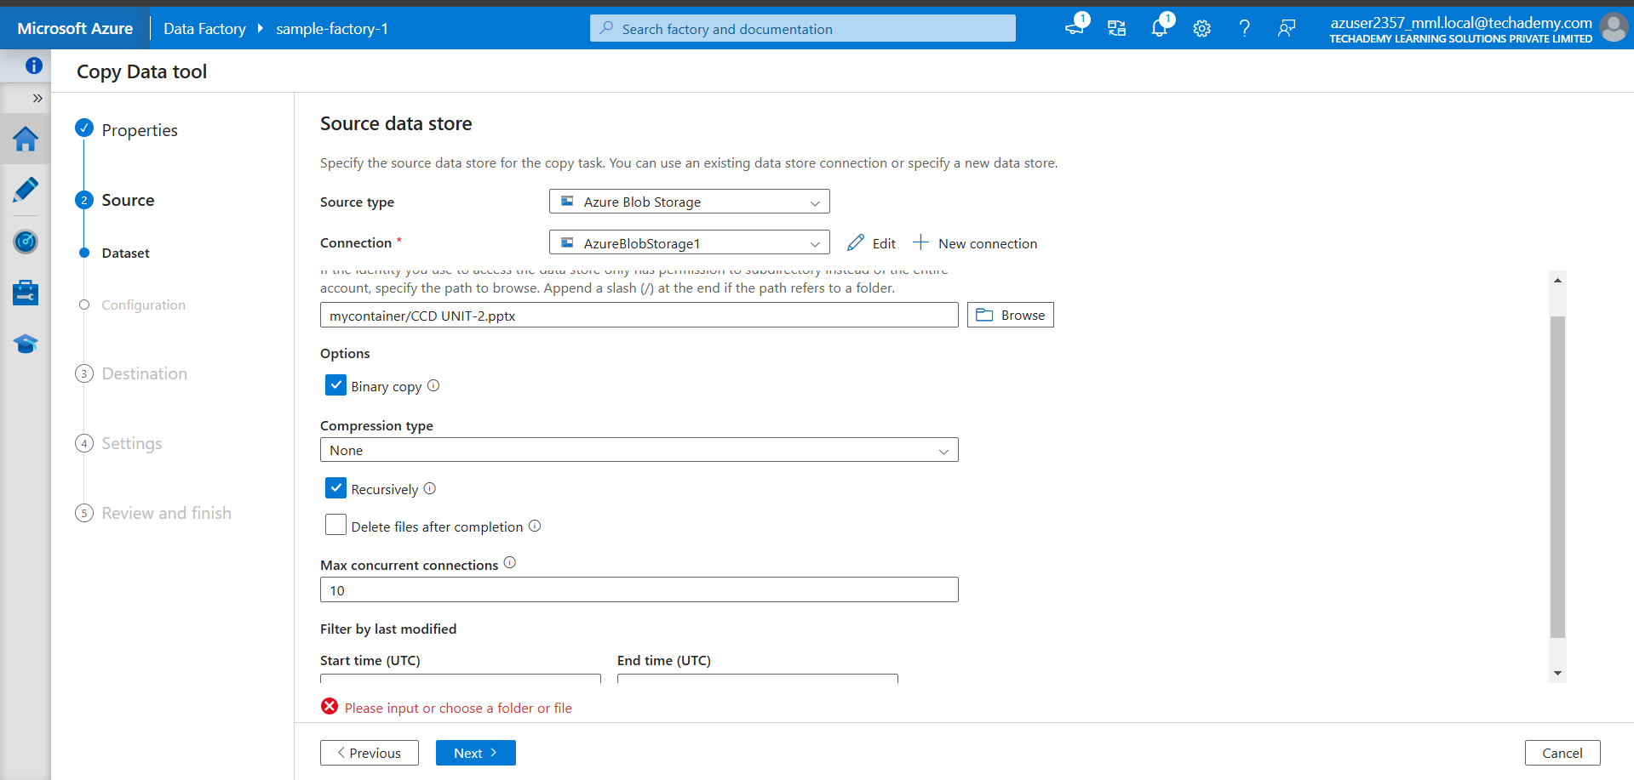

**Step 3: Review and Run**

1. Review all configurations: Source, destination, mapping, and schedule.
2. Click **Next** and then **Finish** to execute the task immediately

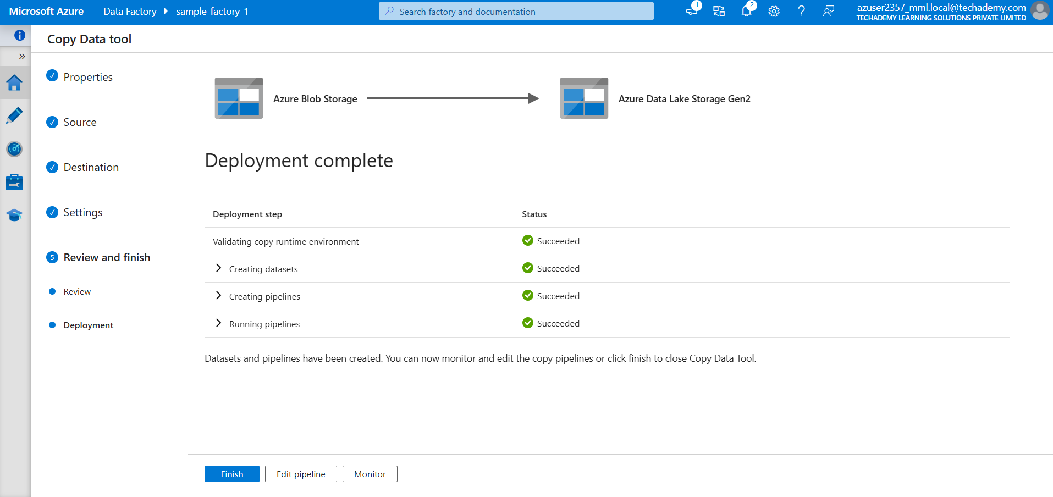

**Step 4: Monitor the Task**

1. After starting the task, navigate to the **Monitor** tab in the Data Factory UI.
2. Check the status of the copy activity and verify that the data transfer was successful.

